IMPLEMENTING CRM FOR RESULT TRACKING OF A CANDIDATE WITH INTERNAL MARKS

# INTRODUCTION:

1.1 OVERVIEW:

Candidate relationship management (CRM) is an approach to manage a student’s interaction with current and potential updates. It uses data analysis about candidate’s history with a data to improve relationship with students, specifically focusing on students internal records. The concepts, procedures, and rules that a corporation follows when communicating with its students detail are referred to as CRM. In this we have a project on CRM for result tracking of a candidate with internal marks is an approach to manage the certificates of school students and college students.

1.2 PURPOSE:

The purpose of this project is to maintain the mark records and develop to create student’s marksheets. Software is a tool that helps to maintain the school, college records. CRM systems compile data from a range of different sites. CRM is a process in which a result or other an organization administers its interactions with students, typically using data analysis to study large amounts of information. CRM may be used with past, present or potential students. It uses data analysis about student’s history with a school to improve the education with students, specifically focusing on student’s result and maintaining the certificate. This complete connection with the student’s internal marks entry and updating details.

# 2.PROBLEM DEFINITION AND DESIGN THINKING:

## 

2.1 EMPATHY MAP:

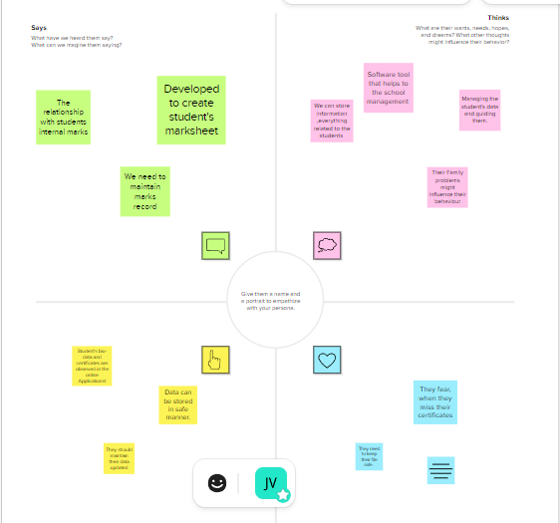

## 2.2 IDEATION AND BRAINSTROMING MAP:

* 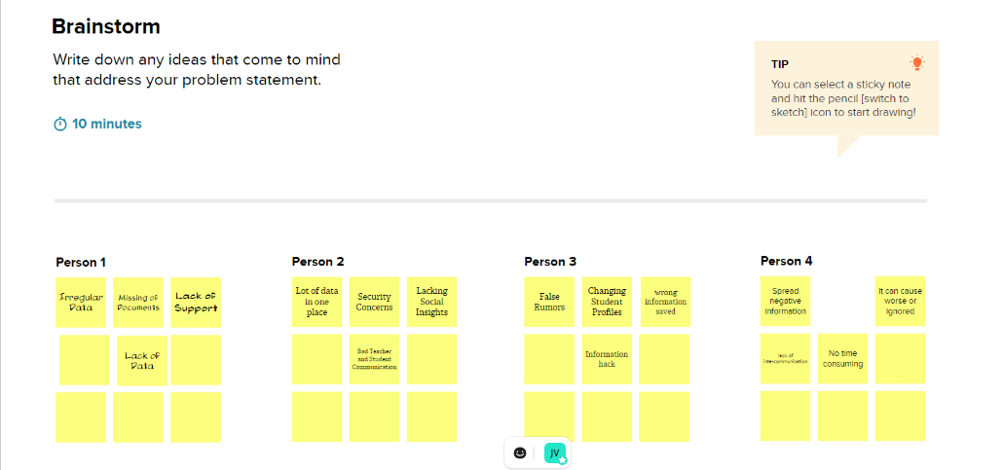

## 3. RESULT:

3.1 DATA MODEL:

|  |  |
| --- | --- |
| OBJECT NAME | FIELDS IN THE OBJECT |
| Semester | FIELD LABEL:  Semester  semesters |
| Candidate | FIELD LABEL:  Candidate  Candidates |
| Course details | FIELD LABEL:  Course  courses |
| Lecturer details | FIELD LABEL:  Lecturer  Lecturers |
| Internal results | FIELF LABEL:  Internal mark  Internal marks |

3.2 ACTIVITY AND SCREENSHOT:

LOG IN TO SALESFORCE ACCOUNT:

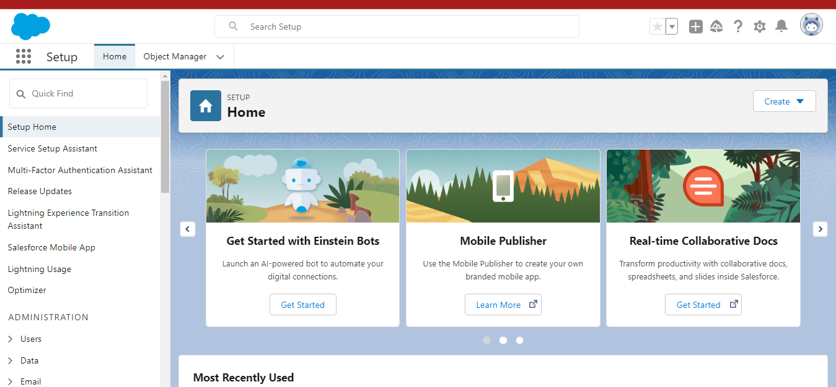

**MILESTONE –2**

## OBJECT:

#### CUSTOM OBJECT:

1.Semester.

2. candidate.

3.course details.

4.Lecturer details.

5.Iternal result.

### ACTIVITY 1

To Navigate to Setup page:

Click on gear icon – click setup.

##### 

TO CREATE AN OBJECT:

From the setup page – click on object manager – click on create – click on custom object.

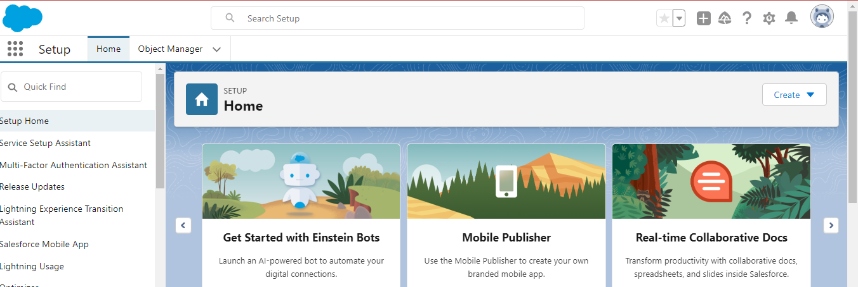

On custom object defining page:

Enter the label name, plural label name, click on allow reports, allow search – save

### On the custom object Definition page, create the object as follows:

1. Lable: Semester
2. Plural: Semesters
3. Record name: Semester name
4. Check the Allow Reports checkbox
5. Check the Allow Search checkbox
6. Click save.
7. Now create a custom tab. Click the Home tab, enter Tabs in Quick find and select tabs.
8. Under custom object tabs, click new.
9. For Object, select Semester.
10. For Tab Style, select any icon.
11. Leave all defaults as is. Click Next, Next and Save.

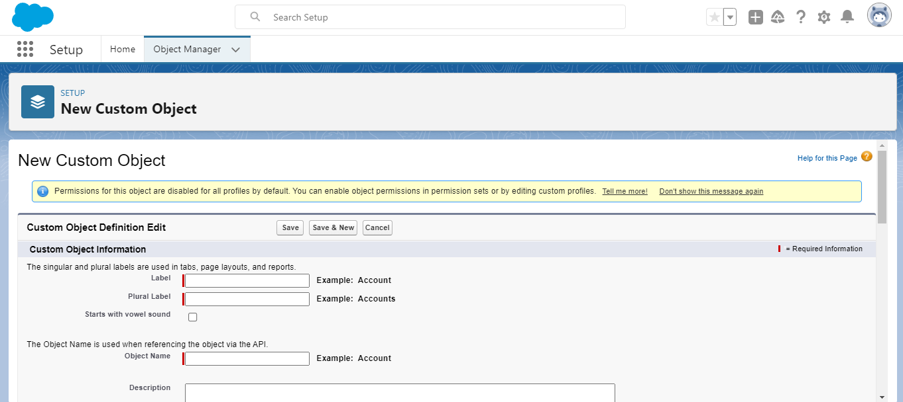

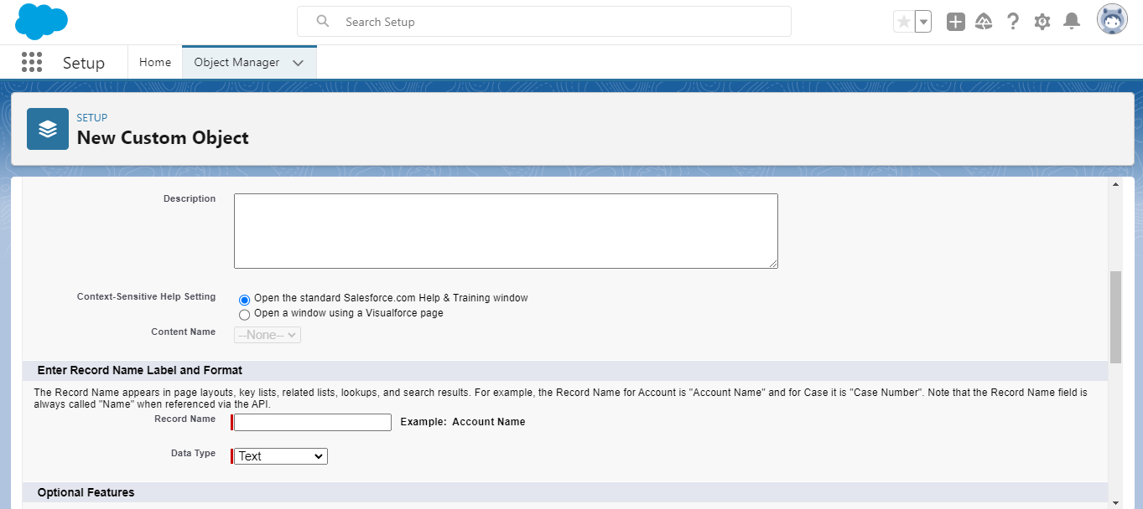

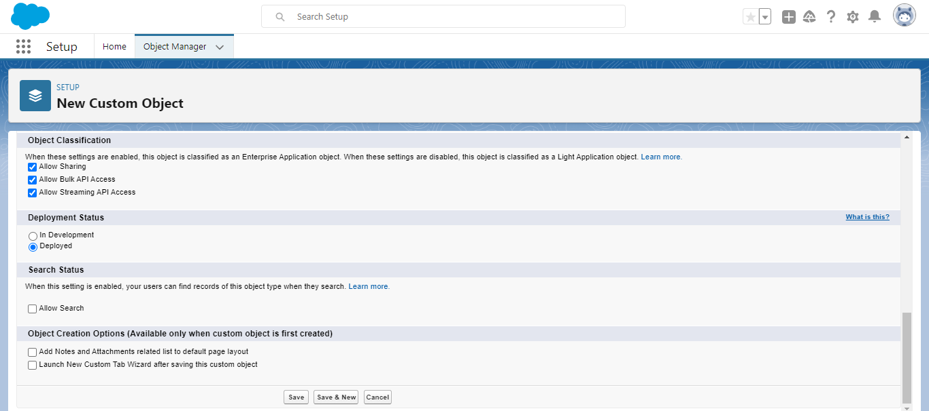

## ACTIVITY –2:

Follow similar steps to create Candidate, Course Details, Lecturer Details, Internal Result Objects.

MILESTONE-2:

**FIELDS AND RELATIONSHIP**

## ACTIVITY-1:

CREATION OF FIELDS:

1.Click the gear icon and select setup. This launches setup in a new tab.

2.Click the Object Manager tab next to home.

3. Select Semester.

4. Select Fields and Relationships from the left navigation, and click New

Now ready to make a custom field. Let's do this!

5.Select the Text as the Data Type, Then Click next.

6. For Field Lable, Enter Semester Name.

7.Click Next, Next then Save.

## TO CREATE FIELDS IN AN OBJECT:

Go to setup- click on Object Manager- type Object name in search bar- Click on the object.

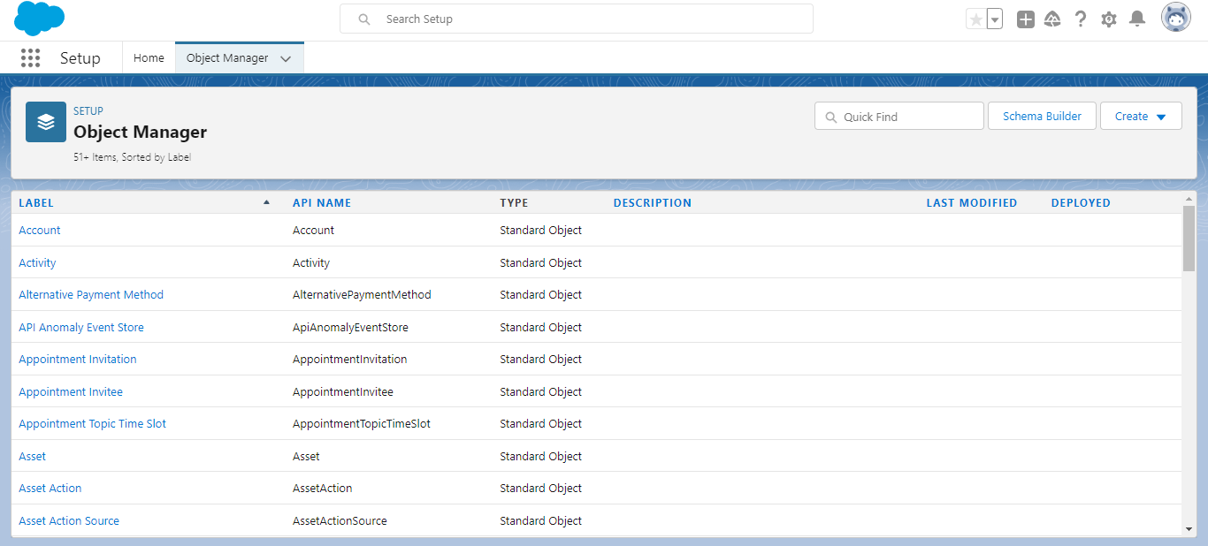

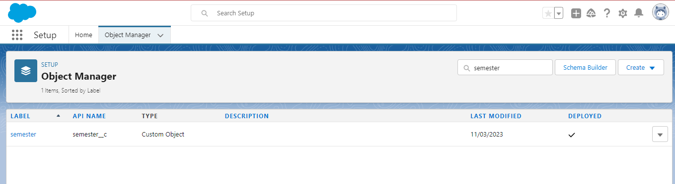

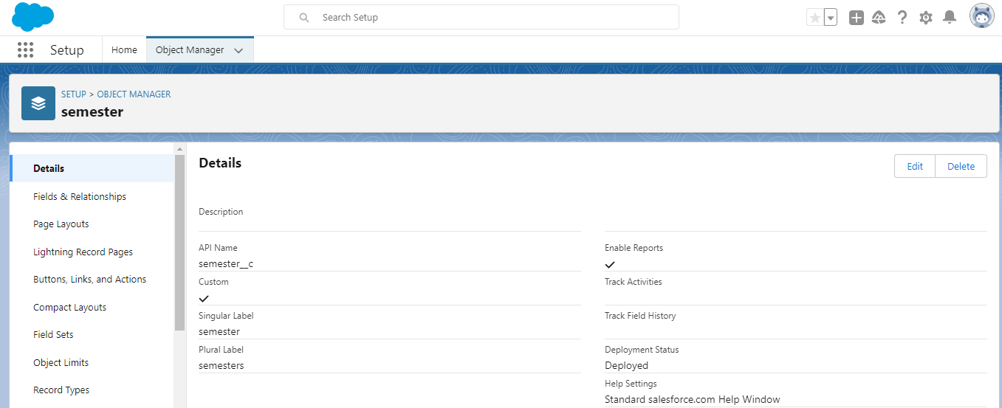

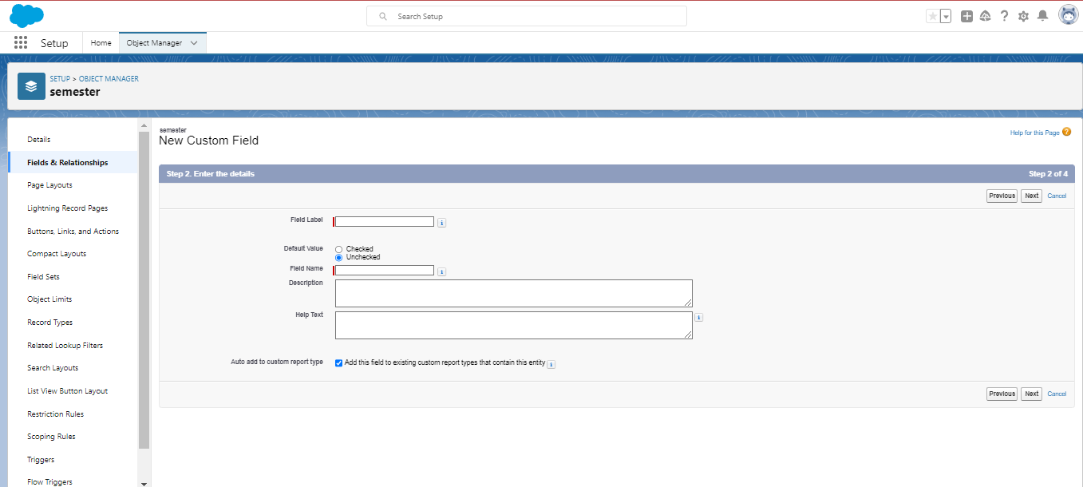

## ACTIVITY-2:

Similarly Create the Following fields according to the Objects.

|  |  |  |  |  |
| --- | --- | --- | --- | --- |
| SEMESTER: | CANDIDATE: | COURSE DETAILS: | LECTURER DETAILS: | INTERNAL RESULTS: |
| semester | Candidate name | Course name | Lecturer Role | Candidate Id |
| Course (lockup) | Candidate Id | Course Id | Lecturer name | Course Id |
|  | Semester name |  | Course Id | Marks |
|  | Internal result(lockup) |  | Course(lockup) |  |

**MILESTONE-3:**

**LIGHTNING APP:**

## ACTIVITY-1:

CREATE THE CANDIDATE INTERNAL RESULT CARD APP:

1. From setup, enter App Manager in the Quick Find and Select App Manager.

2. Click New Lightning App. Enter Candidate Internal Result card as the App Name, then click next.

3. Under App options, leave the default selections and click Next.

4. Under Utility Items, Leave as is and click next.

5. From Available Items, select Semester, Candidate, Course Details, Lecturer Details, Internal Results and move them to selected items. Click next.

6. From Available Profile, Select System Administrator and move it to selected Profiles. Click Save and finish.

7. To verify your changes, click the App Launcher, Type candidate internal result card and select the candidate internal result card app.

**TO CREATE A LIGHTNING APP:**

Go to setup page-Search ‘app manager’ in quick find –select “app manager”- click on New Lightning App.

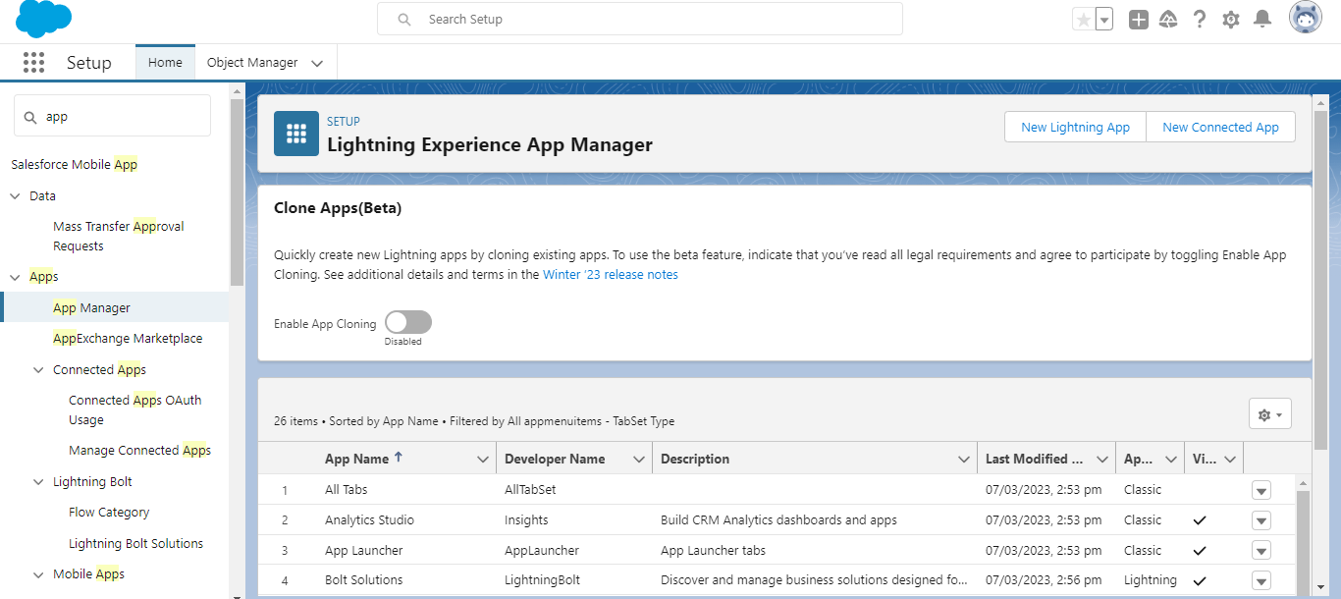

Fill the app name in app details and branding – next- (app option page) keep it as default- next- (Utility items) keep it as default – next- (Add Navigation items)- next- (Add User Profile) add system administrator- next.

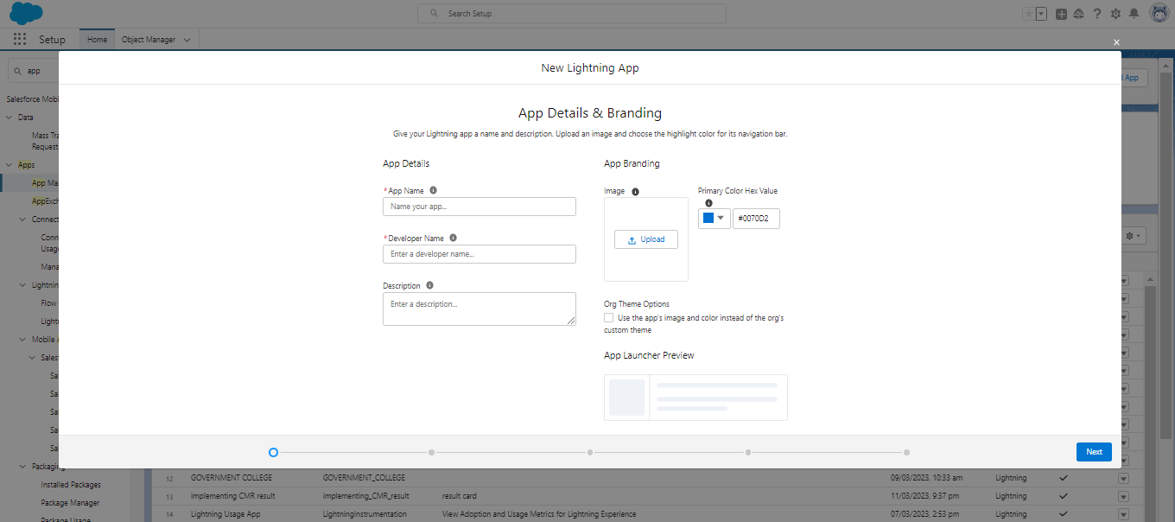

To Add Navigation Items:

Select the items from the search bar and move them using the arrow button – next.

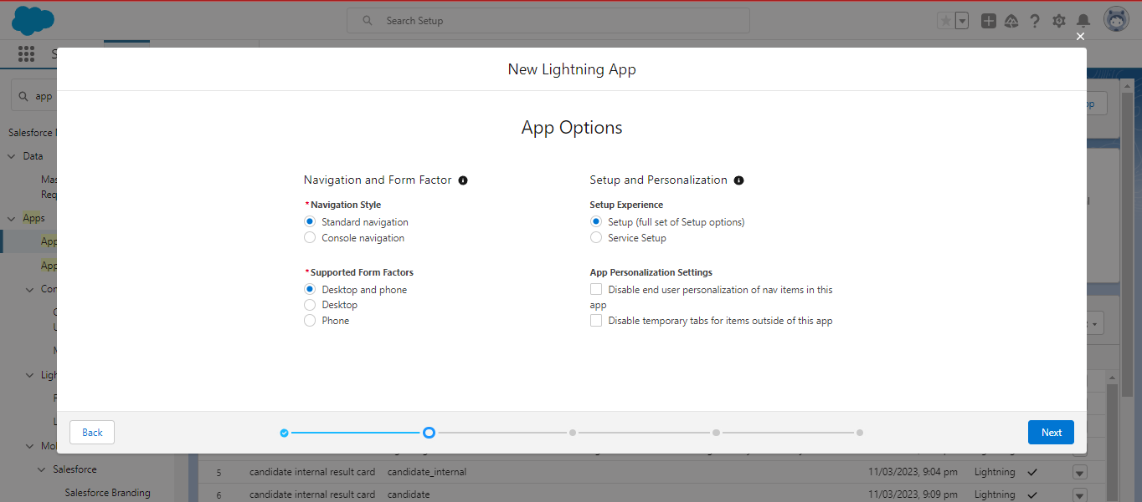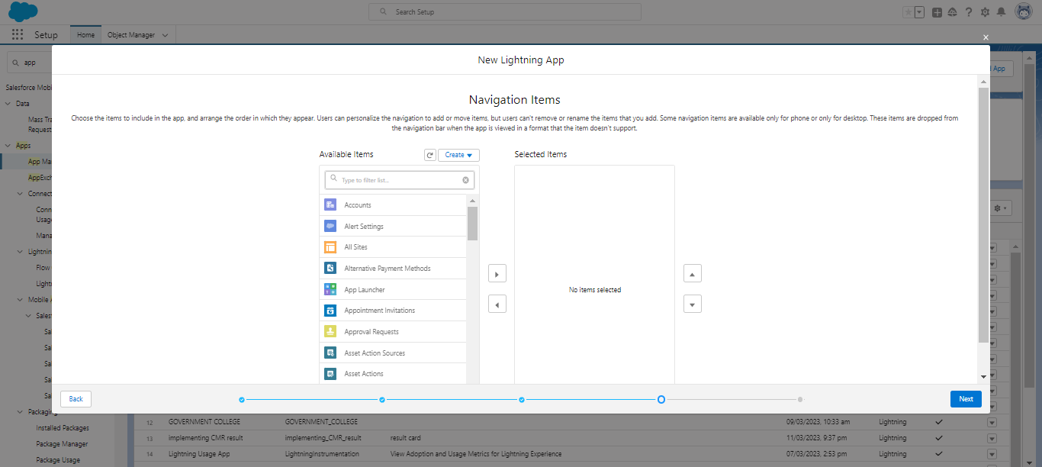

TO ADD USER PROFILES:

Search profiles in search bar – click on the arrow button – save and finish.

MILESTONE-4:

**USERS:**

## ACTIVITY 1:

CREATING A USERS:

1.From setup, in the quick find box, enter users, and then select users.

2. Click New user.

3. Enter the user’s name JHON MARTIN and (your) email address and a unique username in the form of an email address. By default, the username is the same as the email address.

4. Select a Role (none)

5. select a user license as salesforce.

6. Select a profile as salesforce user.

7. Check Generate New password and notify the user immediately to have the user’s login name and a temporary password emailed to your email.

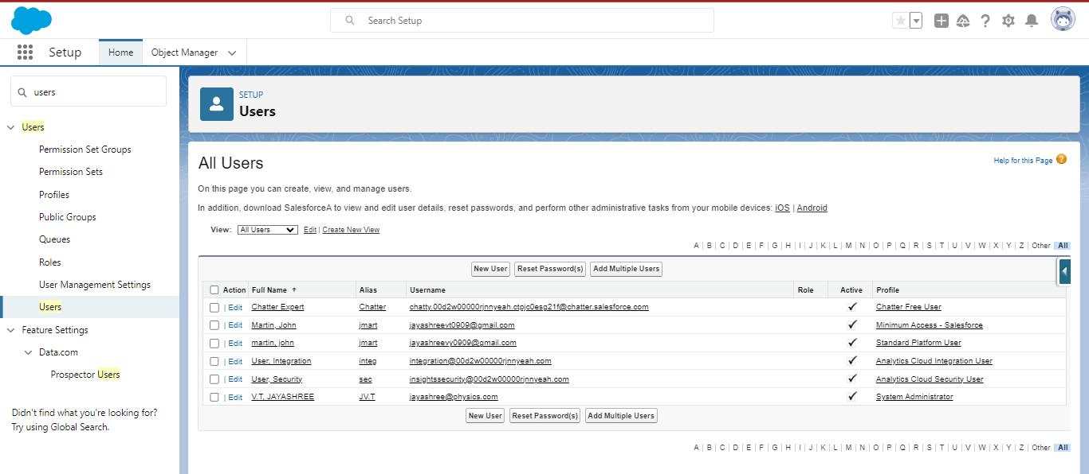

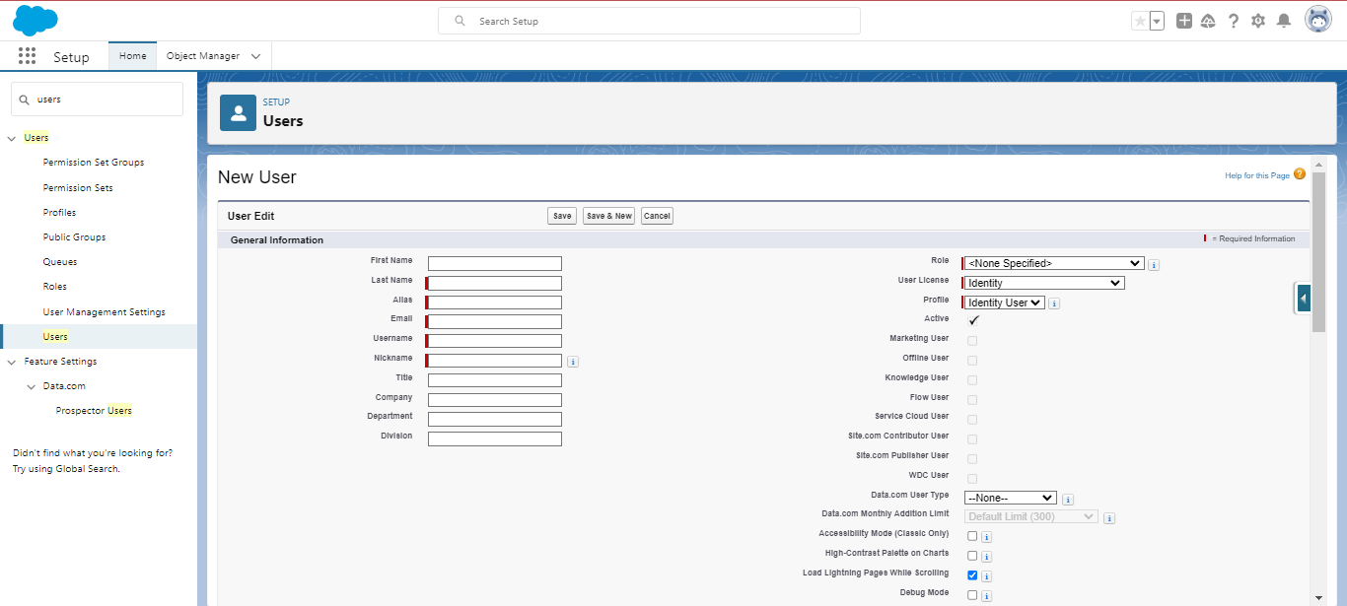

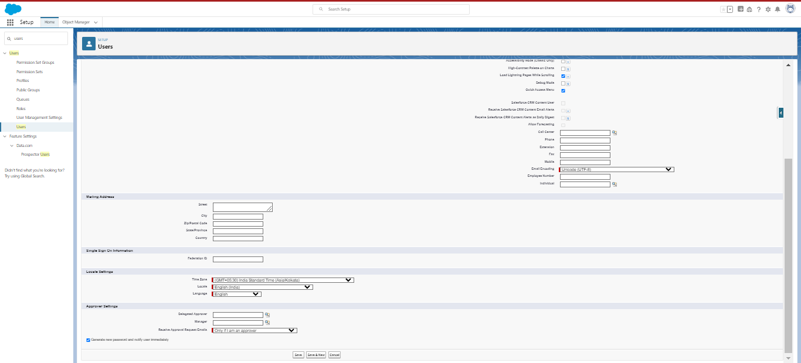

MILESTONE-5:

**REPORTS:**

# ACTIVITY-1:

**REPORTS AND DASHBOARDS:**

1. From the Reports tab, click new reports.
2. Select the report type as candidate with candidate marks for the report and click create.
3. Customize your report, then save or run it.

TO CREATE A REPORT:

Go to the App- click on the reports tab

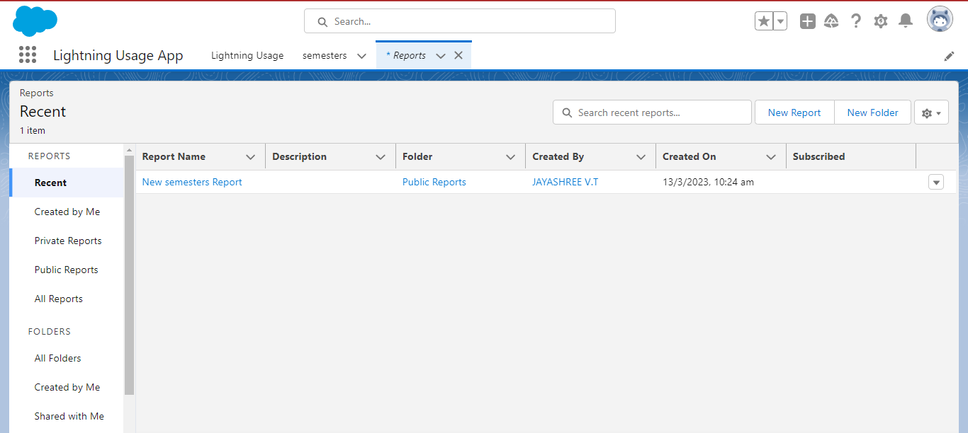

CLICK NEW REPORT

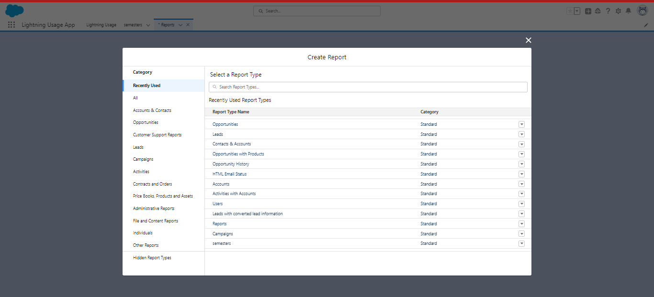

SELECT REPORT TYPE FROM CATEGORY OR FROM REPORT TYPE PANEL OR FROM SEARCH PANEL- CLICK ON START REPORT.

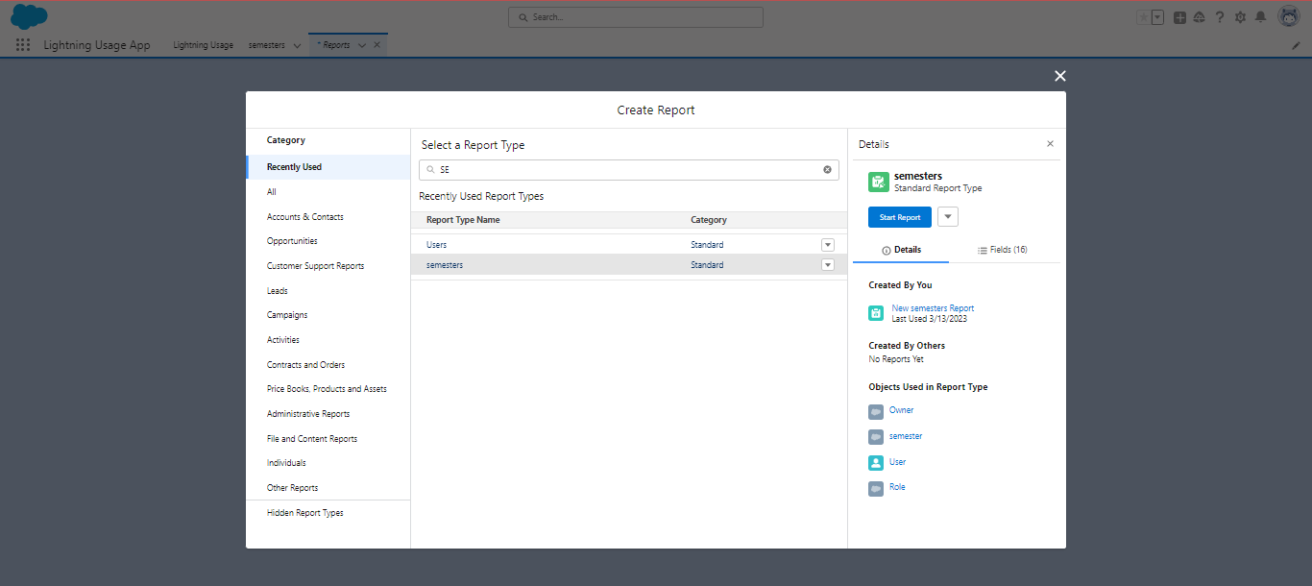

CUSTOMIZE YOUR REPORT, THEN SAVE OR RUN IT.

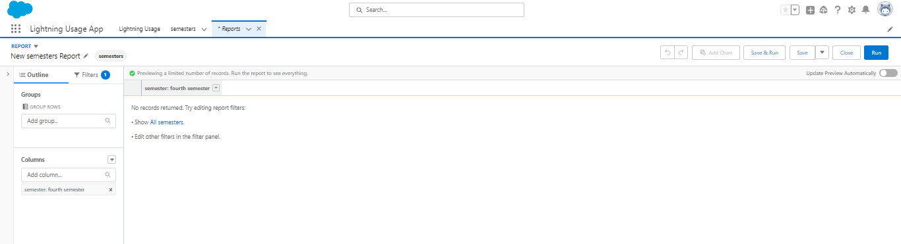

**MILESTONE –6:**

DASHBOARDS:

# ACTIVITY 1:

1. Click the Dashboards tab.

2. Click New Dashboard.

3. Name your dashboard Candidate Board. Leave all other fields as is and click create.

4. Click +component.

5. For Report, Select Candidate Marks by stage. Click select. ….

6. to display as, select vertical bar chart and click Add.

7. Click save.

8. click done.

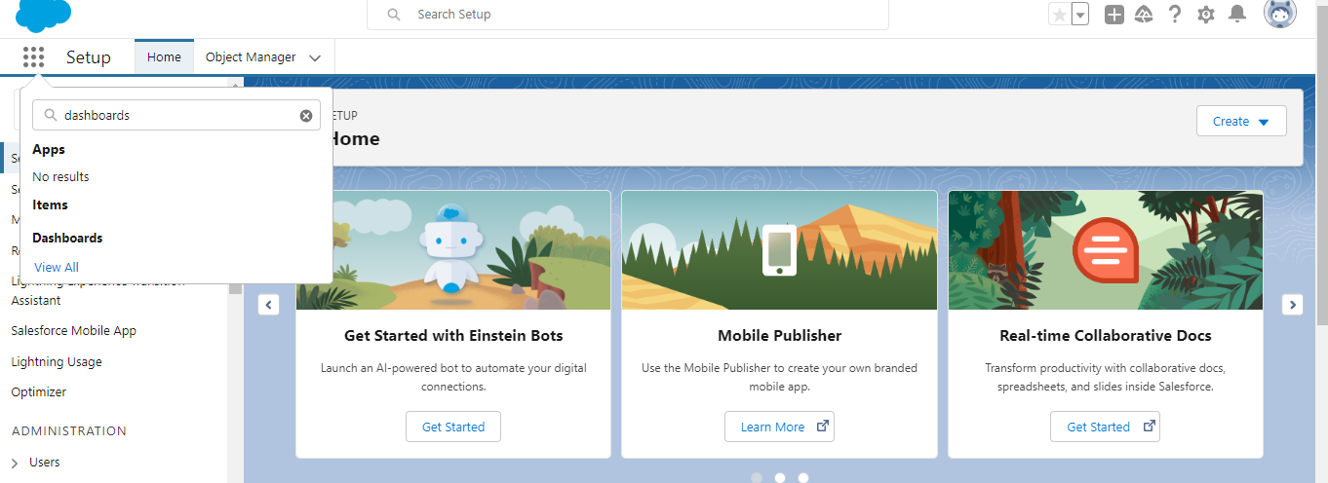

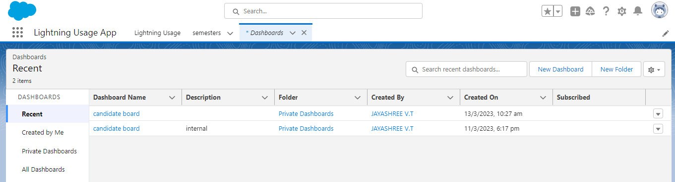

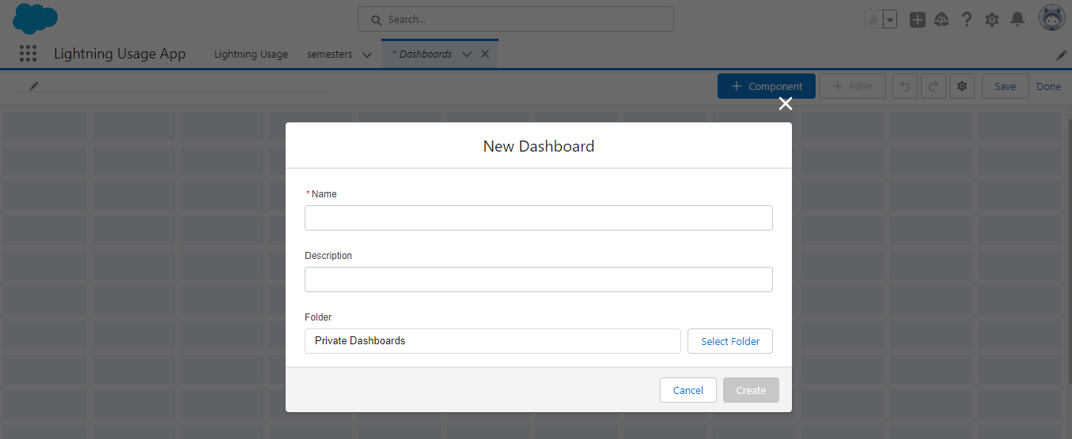

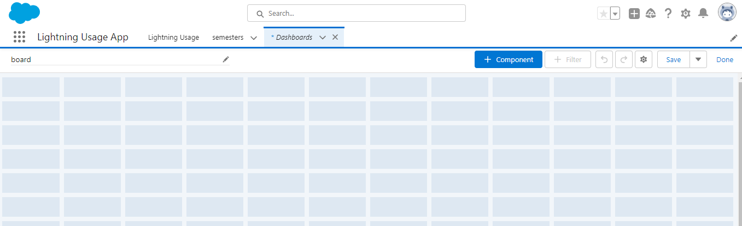

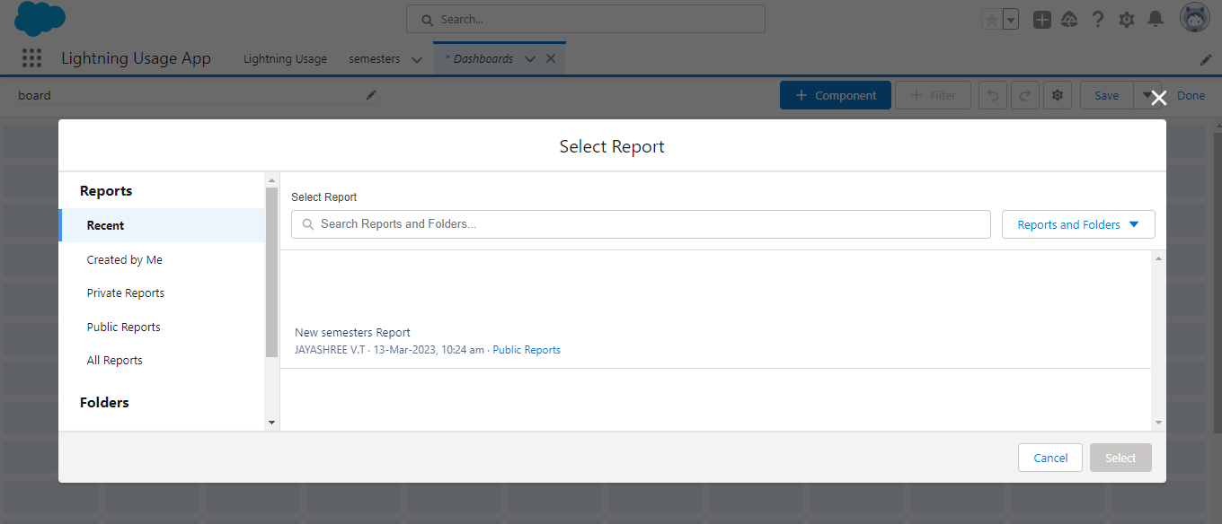

SELECT VERTICAL BAR AND CICK ADD, CLICK SAVE AND CLICK DONE.

1. **TRAILHEAD PROFILE PUBLIC URL:**

**TEAM LEAD- https://trailblazer.me/id/jayvt1**

**TEAM MEMBER 1- https://trailblazer.me/id/vramachandran29**

**TEAM MEMBER 2- https://trailblazer.me/id/sranis**

**TEAM MEMBER 3- https://trailblazer.me/id/swathi324**

PROJECT REPORT TEMPLATE

1. **ADVANTAGES AND DISADVANTAGES:**

Advantages:

1. It allows for more effective sales and marketing.
2. Higher productivity and efficiency.
3. Automated sales force.
4. Opportunity for Longitudinal analysis.
5. More time for data analysis.
6. Minimize cost.
7. Let's pick and choose the functionality that you want.
8. Integrated candidate information.
9. Service provided in a better way and a quicker way.
10. Reanalysis may offer a new interpretation.

DISADVANTAGES:

1. Lack of familiarity with data.

2. Complexity of the data.

3. No control over quality.

4. Absence of key variables.

5. Require continuous maintenance, information updating, and system upgrading cost

6. APPLICATION:

IMPLEMENTING CRM FOR RESULT TRACKING OF A CANDIDATE WITH NTERNAL MARKS:

1. It can be used in both schools and colleges.
2. In schools, colleges and even in universities, it would be very useful in monitoring students' performance and records.

**7. CONCLUSION:**

This solution can be applied in schools and colleges. To maintain the information of the candidates. All certificates should be updated and kept in a proper manner. In Schools, college even in universities. Educational institutions deal with lots of test papers and student evaluation. With this app we can show the students results in graphical representation which makes it easier to manage their results. We have customized objects, fields and created candidate result card app in the app create reports and customized dashboard showing marks of students as vertical bar.

8. FUTURE SCOPE:

CRM startups that focus on how to provide new insights into improving candidate experiences are furnishing.

Positive experiences-built trust, fuel repurchases, create loyalty and lead to higher lifetime candidate values.